C  V | College View Church of Christ  FROM THE ELDERS AND EVANGELISTS
851 North Pine Street
Florence, AL 35630
(256)766-0403
collegeview.org

Dear bROTHERS AND sISTERS
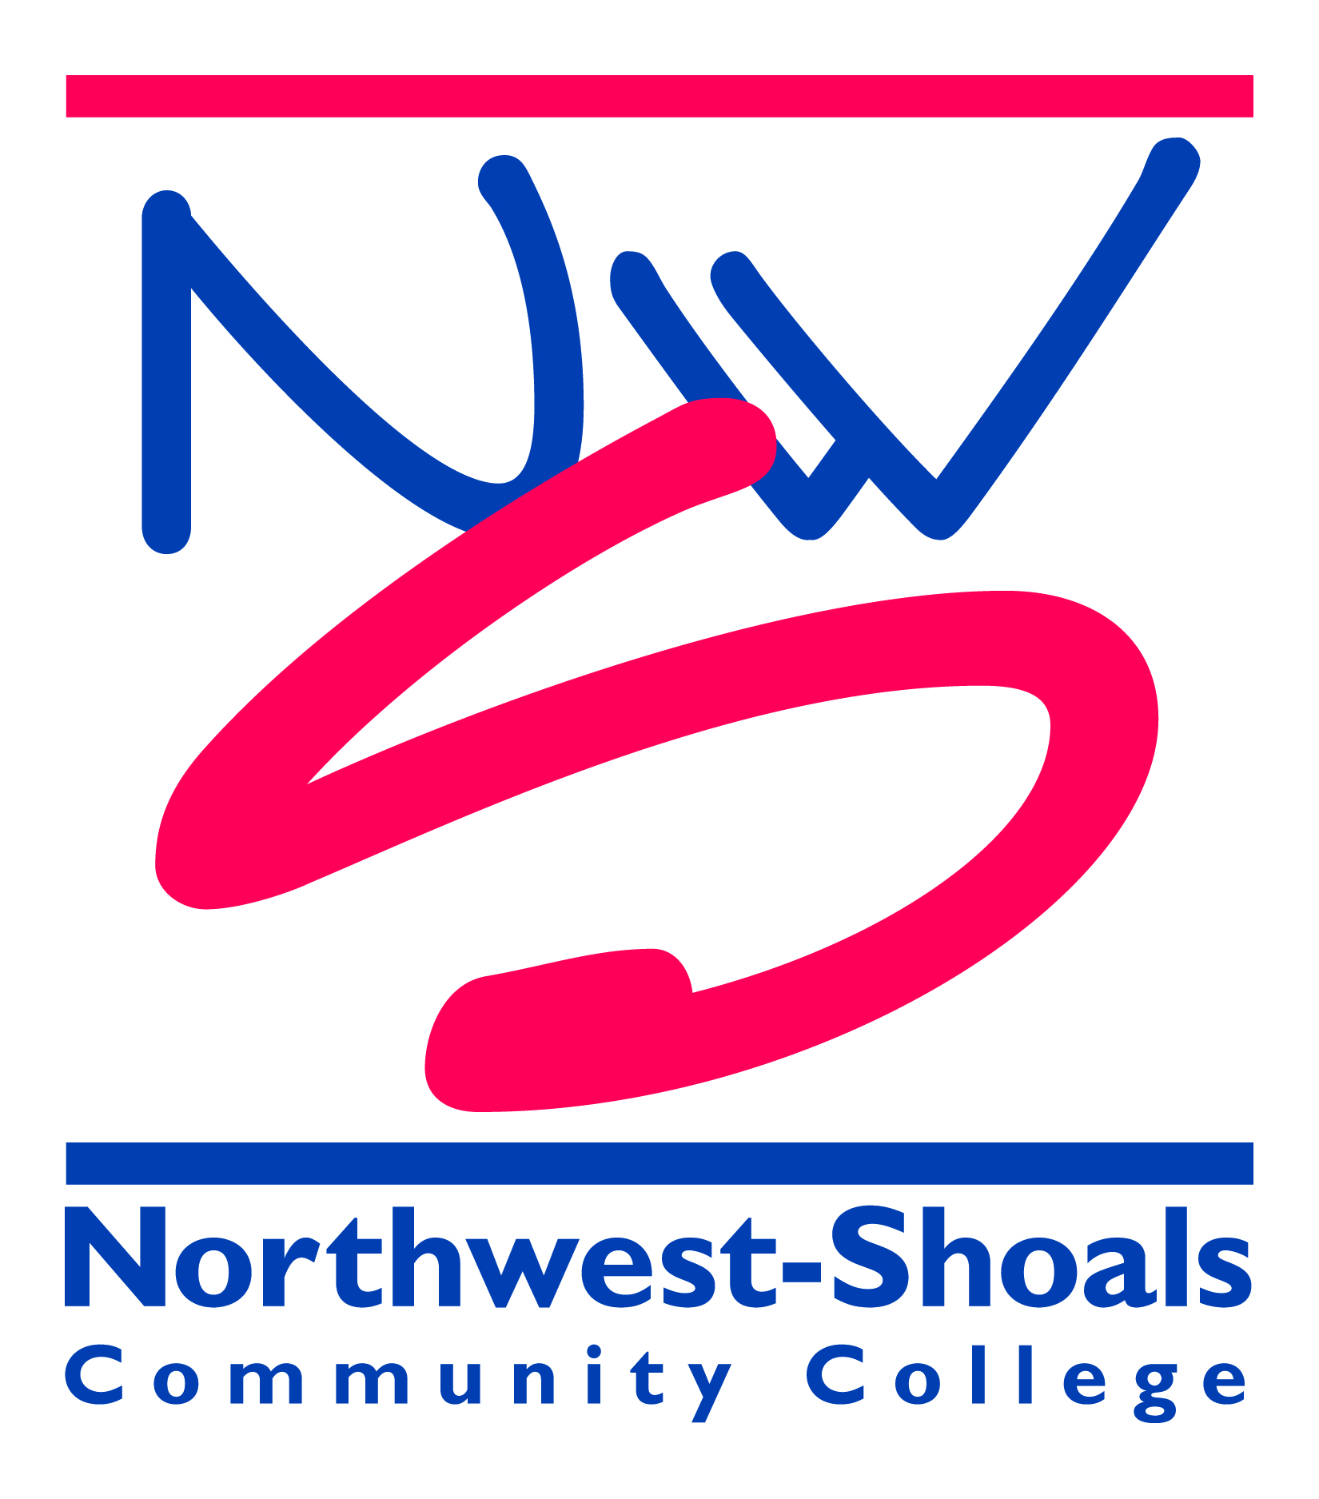
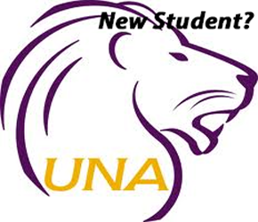
We sincerely thank you for taking the time to read this letter and give attention to it. At the College View church, we are striving to work and worship together as a New Testament local church. (Ephesians 4:16, Acts 2:38-42).
Part of our work at College View is focused on college students. Our building is right next door, literally, to the University of North Alabama's campus and we are not far at all from Northwest Shoals. We know that during a young person's college years their faith can be truly tested, and we are here to help as much as possible during this time. Several of our members work for UNA and Northwest Shoals and can help provide guidance for our college students.
Beginning January 5, 2022 (the first day of class) Kenny Moorer will be teaching the college students on Wednesday nights at 6:30pm through the end of the semester. Kenny and Justin will also be on campus from time to time for a bible study, and our members will have the college students over every other week for a bible study and time together.
If you or your child are planning on living in our area, let us know so we can do our best to help them stay close to the Lord during their college days here. Or visit our website at collegeview.org and choose the contact us tab. We cannot wait to hear from you, and may God bless you as we labor together for His great cause.

Sincerely,

Mitch Bowen, Randy Little, Rob Hibbett and Patrick Sneed- Elders

Kenny Moorer (813-956-6362) and Justin Roberson (256-412-8146) - Evangelists

